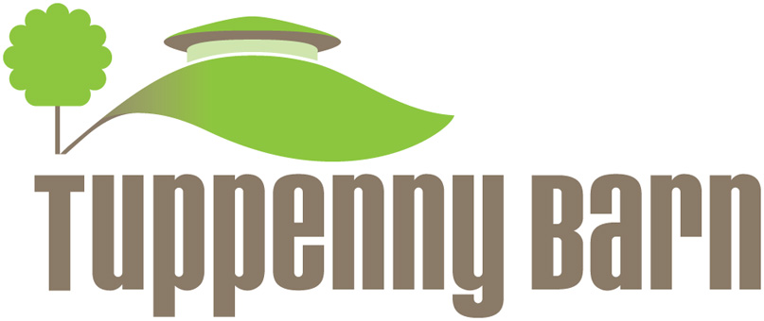

Tuppenny Barn Centre Manager & Communications/ Marketing
Job Description

Salary: £18 – 20k pro rata, dependent on experience
Hours: Four days a week
Location: Southbourne, West Sussex
Contract: Permanent position
Reporting to: CEO

Closing Date
Friday 31st Jan midday

Interviews
Interviews for short listed candidates will be held at Tuppenny Barn on Monday 3rd February

Tuppenny Barn

Tuppenny Barn is located on an award winning organic small holding and its key charitable objective is to provide children with the experience of growing, cooking and eating healthy food, particularly with disadvantaged children. The charity introduces the concepts of sustainability, biodiversity and conservation to the next generation responsible for protecting the environment.

Tuppenny Barn was founded in 2005 and has subsequently grown from a barren hectare of land into a thriving smallholding. The fully accessible education centre is built with environmentally friendly materials and is an instantly recognisable and outstanding icon for the project. It contains a large kitchen where the home grown produce is cooked during classes. The site where fruit and vegetables are grown organically is fully accredited by the Soil Association. It works as an outdoor classroom enabling hands-on experience for children on our programmes. The charity currently reaches out to around 1500 children and young people each year and we are committed to expanding our services. There is a bi-weekly shop and also a weekly organic vegetable bag scheme serving our local community.

Overview of the role

The successful candidate will:

- Provide an efficient administration service to support the effective day-to-day running of the Tuppenny Barn charity
- Promote the aims and activities of the charity and support its fundraising initiatives.
- This role is also responsible for the marketing communications of both Education and Organics
Overall purpose and role

Key Objectives
- Oversee the daily activities and duties of the Centre, dealing with all administrative and operational matters
- Co-ordination of administration of all Tuppenny Barn events
- Marketing and Communications of all Tuppenny Barn events
- Reception Duties
- Diary Management
- Data processing and inputting
- Administration of the private hire of the centre

Activities and Duties
- ‘Front of House’ for all centre enquiries from members of the public via phone, email, face-to-face
- Responsible for TB personnel administration, including holiday records, DBS paperwork etc
- Assisting with all elements of Centre Security, Health & Safety
- Co-ordination of facilities management for the Centre
- Overseeing the smooth running of the Centre IT system and liaising with external parties for maintenance
- Running regular social media campaigns for all Tuppenny Barn events and fundraising
- Co-ordination of marketing posters and fliers
- Private Hire - Assisting with private hire from initial enquiry through to delivery
- TB Events – Assist with co-ordination and execution of events
- Compilation of the 6 monthly events flier
- Support CEO and other staff members – assist CEO when required.
- Deputise for CEO and any other staff to ensure continuity of business
- Key holder

Skills and Requirements

Essential

- Excellent written and spoken communications
- Excellent interpersonal skills
- Ability to promote Tuppenny Barn activities via current social media platforms (Facebook/Twitter/Instagram)
- IT literate – MS Office
- Reliable and able to use own initiative
- Occasional weekend work
- This is an extremely busy role, so flexibility and a sense of humour will certainly help
- Clean driving license
- Ability to work as a team member
- Excellent planning and organisational skills
- A positive attitude and ability to multi-task, work well under pressure and work pro-actively
- Interest in the environment and sustainability

Desirable

- Experience of working in the charity and voluntary sector
- Knowledge of Mailchimp and WordPress

